Wargrave Rec and Kings Field
Please note that dogs are not permitted on the Recreation Ground or King Field
All our teams have at least one FA qualified first aider and a First-Aid kit. If you have a qualified first aider, please can you let your contact at WWGFC know.
Medical Emergency Action Plan

Club Name |  | Wargrave Women and Girls FC
Team Name
Manager/ Lead Coach
Mobile number
Today you are playing on pitch number
Nearest Minor Injuries Unit | Townlands Memorial Hospital,  York Road, Henley-on-Thames, Oxfordshire, RG9 2EB  Tel: 01865 903703  Open: 0900 – 2000
Nearest Accident and Emergency | Royal Berkshire Hospital,  Craven Road  Reading  RG1 5AN  Tel: 0118 322 5111
Nearest Defibrillator | On the outside of the Parish office which is the first building you reach upon entry from Recreation road
Access for Ambulance | Via Recreation Road in to car park shown on map below
Address for Ambulance | Wargrave Recreation Ground, Recreation Road, Wargrave, RG10 8BG (pitches 1 and 2)  Or East View Road, Wargrave, RG10 8BH (Kings Field)
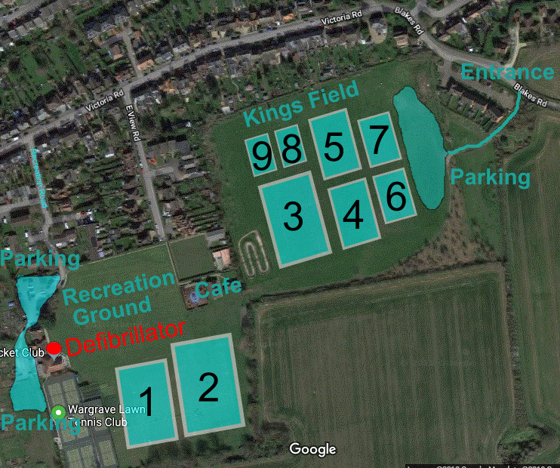

Toilet

