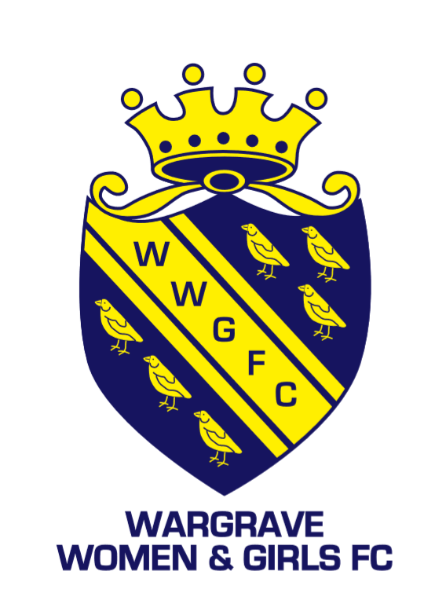
Piggott School
Twyford Road, Wargrave, RG10 8DS

All our teams have at least one FA qualified first aider and a First-Aid kit. If you have a qualified first aider, please can you let your contact at WWGFC know.
Medical Emergency Action Plan

Club Name |  | Wargrave Women and Girls FC
Team Name
Manager/ Lead Coach
Mobile number
Nearest Minor Injuries Unit | Townlands Memorial Hospital,  York Road, Henley-on-Thames, Oxfordshire, RG9 2EB  Tel: 01865 903703  Open: 0900 – 2000
Nearest Accident and Emergency | Royal Berkshire Hospital,  Craven Road, Reading, RG1 5AN, Tel: 0118 322 5111
Nearest Defibrillator | On the outside of the PE hall
Access for Ambulance | Via A321– following blue arrows below through school car park – dotted line marks route on foot
Address for Ambulance | Piggott School, Twyford Road, Wargrave, RG10 8DS
