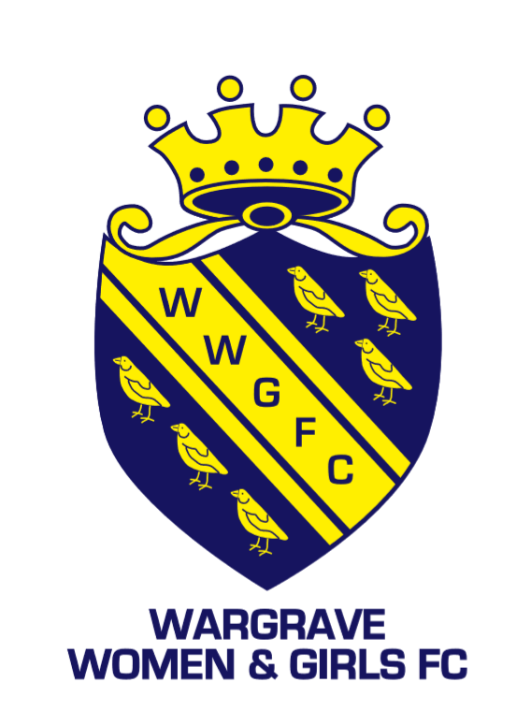
Wargrave match at Cantley Park
Match info
All our teams have at least one FA qualified first aider and a First-Aid kit. If you have a qualified first aider, please can you let your contact at WWGFC know.
Club Name |  | Wargrave Women and Girls FC
Home Team Name
vs Opposition team name :-
Manager/ Lead Coach
Mobile number
Date & Time
You are playing on pitch number |  | Pitch 8: Cantley Park, Twyford Road, Wokingham RG40 5QG
Nearest Accident and Emergency | Royal Berkshire Hospital,  Craven Road  Reading  RG1 5AN  Tel: 0118 322 5111
Nearest Defibrillator | On pavilion by café (by 4g)
Access for Ambulance | The access to the pitches for services is near the front entrance and the code is 3728.  We have staff on site if an incident occurs and we also have a defibrillator stationed on the wall of the pavilion (near the café)  Staff tend to be around pavilion or 4G
Address for Ambulance | Cantley Park, Twyford Road, Wokingham RG40 5QG

Additional parking: Please use Holt Lane or Jubilee Avenue. Please respect local residents by parking considerably. Pitches=10 minute walk
A temporary path has been installed and please exercise caution when climbing the stile and using the path
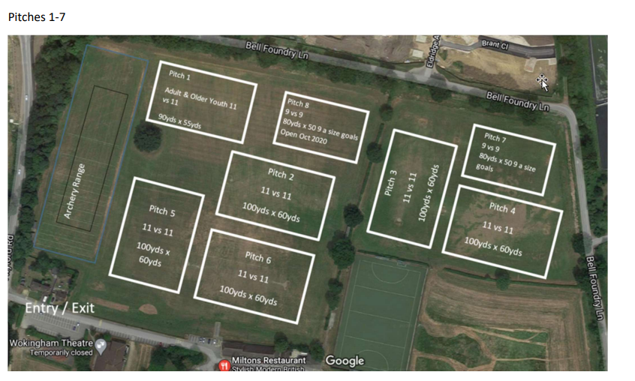
Note pitch 6 below is now the 4G pitch

